**[Installation & Setup](http://laravel.com/docs/5.1/homestead" \l "installation-and-setup)**

#### Installing The Homestead Vagrant Box

vagrant box add laravel/homestead

Another option:

vagrant box add laravel/homestead <https://atlas.hashicorp.com/laravel/boxes/homestead>

#### Cloning the the Homestead Repository

git clone https://github.com/laravel/homestead.git Homestead

consider:menganggap

git clone https://github.com/laravel/homestead.git Homestead

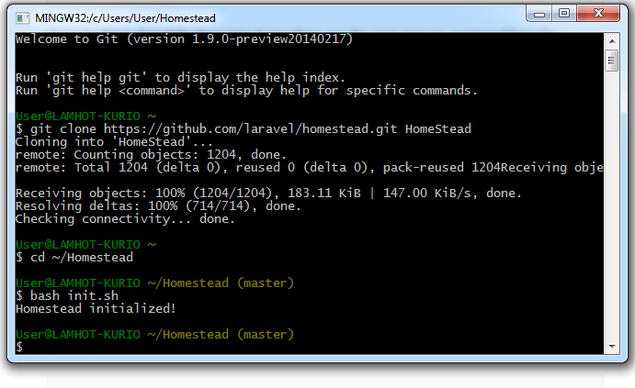

Initialization: Use this command

bash init.sh

Configuring Homestead

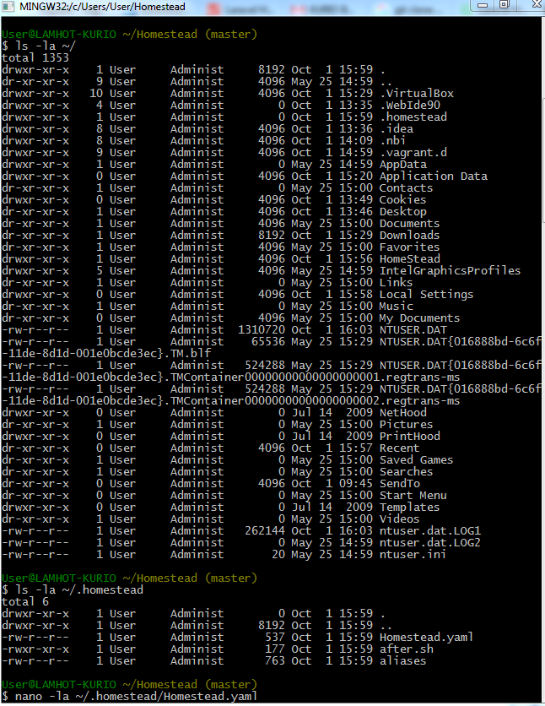

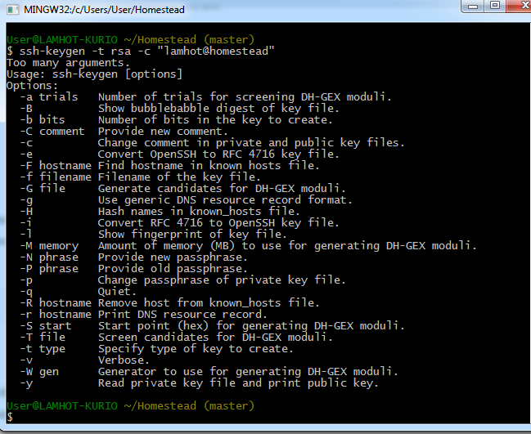

That is cli after using this command: ssh-keygen -t rsa -C "lamhot@homestead"

Here command that using in CMD

vagrant@homestead:~$ ls ~/.ssh

authorized_keys id_rsa known_hosts

vagrant@homestead:~$ ssh-keygen -t rsa

Generating public/private rsa key pair.

Enter file in which to save the key (/home/vagrant/.ssh/id_rsa):

/home/vagrant/.ssh/id_rsa already exists.

Overwrite (y/n)? y

Enter passphrase (empty for no passphrase):

Enter same passphrase again:

Your identification has been saved in /home/vagrant/.ssh/id_rsa.

Your public key has been saved in /home/vagrant/.ssh/id_rsa.pub.

The key fingerprint is:

97:3b:b9:7e:37:89:50:f5:08:da:d4:8d:56:4c:22:fb vagrant@homestead

The key's randomart image is:

+--[ RSA 2048]----+

| ...*o|

| oo=.o|

| +.+ o |

| ..o.. .|

| S o. E |

| ..o |

| +. . . |

| oo + |

| .o. . . |

+-----------------+

vagrant@homestead:~$ ls ~/.ssh

authorized_keys id_rsa id_rsa.pub known_hosts

vagrant@homestead:~$ cat .ssh/id_rsa.pub

ssh-rsa AAAAB3NzaC1yc2EAAAADAQABAAABAQC+BXR3diR/u/GQ/o/vxdGNv7uPlKgA9jQ9A+ZOP6QU6Y9qOdF0lDye/W8tAdWDUxX0gZR1YudVinThtl7wIYcl7lF6KhaGRXC3PacU8v87NCTgF+3X56d47ZiiZ38tNobMg80LAAGB X0BvLwzYyhCTvjIta+tQT8kBneNMV32DZsOpildlr5ymRrnpZbYs9gDIOw9Lc/UxsbgOJTpQkGAL1KbuexDQQNi7UC+6ddwfy2LMetT1ScZToPBtV8QFMFPq1FIxnBKSFDAsXlROMA4hpsd6Gtpbr3VMStD0myWqvyIwjWbabeW12zKb qAACBZJeE3wQyQYP73AFviZrmXmT vagrant@homestead

vagrant@homestead:~$ cd kurio-admin

vagrant@homestead:~/kurio-admin$ composer install

You are running composer with xdebug enabled. This has a major impact on runtime performance. See https://getcomposer.org/xdebug

Loading composer repositories with package information

Installing dependencies (including require-dev) from lock file

- Installing simplepie/simplepie (1.3.1)

Loading from cache

C:\Program Files (x86)\OpenVPN\bin;C:\Users\User\AppData\Roaming\npm;C:\Program Files\Java\jdk1.8.0\bin;C:\Python27;C:\Go\src;;C:\Program Files\Docker Toolbox

C:\ProgramData\Oracle\Java\javapath;%SystemDrive%\MMSAutomation\versions\bin;C:\Program Files (x86)\Intel\iCLS Client\;C:\Program Files\Intel\iCLS Client\;%SystemRoot%\system32;%SystemRoot%;%SystemRoot%\System32\Wbem;%SYSTEMROOT%\System32\WindowsPowerShell\v1.0\;C:\Program Files\Intel\Intel(R) Management Engine Components\DAL;C:\Program Files\Intel\Intel(R) Management Engine Components\IPT;C:\Program Files (x86)\Intel\Intel(R) Management Engine Components\DAL;C:\Program Files (x86)\Intel\Intel(R) Management Engine Components\IPT;C:\Program Files (x86)\ATI Technologies\ATI.ACE\Core-Static;C:\Program Files (x86)\Skype\Phone\;C:\HashiCorp\Vagrant\bin;C:\Program Files\TortoiseGit\bin;C:\Program Files\Java\jdk1.8.0\bin;C:\Program Files (x86)\nodejs\;C:\Program Files (x86)\Google\Cloud SDK\google-cloud-sdk\bin;C:\Python27;C:\Go\bin;C:\Windows\System32\cmd.exe;C:\Python27\Scripts;

C:\Users\User\Envs\myproject\mongocrud>pip install django-rest-framework-mongoen

gine==2.0.2

pip install -r requirements.txt

python manage.py runserver